# **ONLINE LEARNINGPLATFORM**

### **PROJECT REPORT**

#### **Submitted by**

#### **Group/Team No: G13/PG-3**

**PRABHAT SONI, 2310991013,**

**PRABHPREET KAUR , 2310991014,**

**PRAKHAR TOMAR, 2310991015**

#### **in partial fulfillment for the award of**

#### **the degree of**

## **BACHELEOR OF ENGINEERING**

***in***

COMPUTER SCIENCE & ENGINEERING



**CHITKARA UNIVERSITY**

**CHANDIGARH-PATIALA NATIONAL HIGHWAY**

**RAJPURA (PATIALA) PUNJAB-140401 (INDIA)**

June,2024

**INDEX**

|  |  |  |
| --- | --- | --- |
| S.NO | CONTENT | SIGNATURE |
| **1** | **INTRODUCTION** | **2-3** |
| **2** | **LITERATURE REVIEW** | **4-11** |
| **3** | **DESIGN** | **12-13** |
| **4** | **METHODOLOGY** | **14-16** |
| **5** | **TECHNOLOGY** | **17-20** |
| **6** | **PLATFORM** | **21-23** |
| **7** | **FUTURE SCOPES** | **24-25** |
| **8** | **CODE OF THE PROJECT** | **26-45** |
| **9** | **Collaborating with GitHub** | **46-53** |
| **10** | **CONCLUSIONS** | **54-55** |
| **11** | **REFERENCE** | **56** |

##### 

**\**

**CHAPTER 1**

__________________________________________________________________________________

**INTRODUCTION**

E-learning is an education via the Internet, network, or standalone computer. E-learning is basically the network- enabled convey of skills and knowledge. E-learning refers to using electronic applications and processes to learn. E-learning includes all forms of electronically supported learning and teaching

The information and communication systems, whether networked learning or not, serve as specific media to implement the learning process. This often involves both out-of-classroom and in- classroom educational experiences via technology, even as advances continue in regard to devices and curriculum. E-learning is the computer and network-enabled transfer of skills and knowledge. E-learning applications and processes include Web-based learning, computer-based learning, virtual education opportunities and digital collaboration. Content is delivered via the Internet, intranet/extranet, audio or video tape, satellite TV, and CD-ROM. That is to say E-learning systems contain both Learning Management System and Course management system. It can be self-pace or instructor-led and includes media in the form of text, image, animation, streaming video and audio. It is commonly thought that new technologies can make a big difference in education. In young ages especially, children can use the huge interactivity of new media, and develop their skills, knowledge, and perception of the world, under their parents' monitoring, of course.

With the increasing adoption of the Internet and rise in awareness about e-learning, the online education industry is expected to witness promising growth during the forecast period. Ease of learning, flexibility, and a wide range of study materials have influenced the overall growth of the industry. The online education market is segmented into primary and secondary supplemental education, test preparation, reskilling and certification, higher education language, and casual learning. The change in consumer behaviour towards detailed learning and surge in demand from tier II and tier III cities are driving the growth of this segment. The online test preparation market is expected to reach INR 94.75 Bn by 2024. This segment is expected to be the fastest-growing segment in the online education market.

lOMoARcPSD|31593198

E- Learning education is an electronically supported learning system, which relies on the Internet for interaction and distribution of course material between students and teachers. Growing demand to reduce the cost of education, increasing government initiatives supporting online education, and increasing penetration of smartphones and the Internet are the factors contributing to the growth of the global online education market. Additionally, the market is also expected to be boosted owing to the increasing demand for adaptive learning. However, the availability of abundant free content and lack of awareness is limiting the market growth.

Many proponents of e-learning believe that everyone must be equipped with basic knowledge InTechnology, as well as use it as a medium to reach a particular goal and aim. In the 20th century, we have moved from the Industrial Age through the Information Age and now to the Knowledge Age. Knowledge and its efficient management constitute the key to success and survival for organizations in the highly dynamic and competitive world of today. Efficient acquisition, storage, transfer, retrieval, application, and visualization of knowledge often distinguish successful organizations from the unsuccessful ones.

E-learning is bridging the gap between learning and work. Workers can integrate learning into work more effectively because they use the same tools and technology for learning as they use for work. Both employers and employees recognize that e-learning will diminish the narrowing gap between work and home, and between work and learning.E-learning is an option to any organization looking to improve the skills and capacity of its employees. With the rapid change in all types of working environments, especially medical and healthcare environments, there is a constant need to rapidly train and retrain people in new technologies, products, and services found within the environment. There is also a constant and unrelenting need for appropriate management and leveraging of the knowledge base so that it is readily available and accessible to all stakeholders within the workplace environment

**1.1 ADVANTAGES OF E- LEARNING**

**Effectiveness: -** E-learning offers teachers an efficient way to deliver lessons to students. Online learning has a number of tools such as videos, PDFs, podcasts, and teachers can use all these tools as part of their lesson plans. By extending the lesson plan beyond traditional textbooks to include online resources, teachers are able to become more efficient educators.

lOMoARcPSD|3159319

**Accessibility Of Time and Place: -** Another advantage of online education is that it allows students to attend classes from any location of their choice. It also allows schools to reach out to a

more extensive network of students, instead of being restricted by geographical boundaries. Additionally, online lectures can be recorded, archived, and shared for future reference. This allows students to access the learning material at a time of their comfort.

**Affordability: -** Another advantage of online learning is reduced financial costs. Online education is far more affordable as compared to physical learning. This is because online learning eliminates the cost points of student transportation, student meals, and most importantly, real estate.

Additionally, all the course or study materials are available online, thus creating a paperless learning environment which is more affordable, while also being beneficial to the environment.

**Suits a variety of learning Styles: -**

Every student has a different learning journey and a different learning style. Some students are visual learners, while some students prefer to learn through audio. Similarly, some students thrive in the classroom, and other students are solo learners who get distracted by large groups. The online learning system, with its range of options and resources, can be personalized in many ways. It is the best way to create a perfect learning environment suited to the needs of each student.

**1.2 INTRODUCTION TO PROJECT**

Website is the delivery of learning and training through digital resources. Although It is based on formalized learning, it is provided through electronic devices such as computers, tablets and even cellular phones that are connected to the internet. This makes it easy for users to learn anytime, anywhere, with few, if any, restrictions. Basically, It is training, learning, or education delivered online through a computer or any other digital device.

It is an online platform developed for the purpose of live coaching. It facilitates live coaching classes for 1th to 10th-grade students. The platform is also dedicated to the training for several Courses such as the Machine Learning, Programming Languages, Video Editing etc.

To offer its support to the 21st century’s education system, the platform allows LIVE interactive online learning amidst the pupils and teachers. It also offers individual as well as group classes. The platform makes use of two-way audio, video as well as whiteboarding tools which enables both the student as well as the teacher to view, listen, write as well as interact in real-time.

**1.3 AIM AND OBJECTIVE OF THE PROJECT**

E-Learning represents an innovative shift in the field of learning, providing rapid access to specific knowledge and information. It offers online instruction that can be delivered anytime and anywhere through a wide range of electronic learning solutions such as Web-based courseware, online discussion groups, live virtual classes, video and audio streaming, Web chat, online simulations, and virtual mentoring. E-Learning enables organizations to transcend distance and other organizational gaps by providing a cohesive virtual learning environment. Companies must educate and train vendors, employees, partners, and clients to stay competitive and E-Learning can provide such just-in-time training in a cost-effective way.

Developing and deploying effective E-Learning programs may require products and services supplied by a variety of vendors, leaving one to connect the dots. One way to start is to define the goals of the desired learning solution. Definition of the goals of an E-Learning solution is driven by the following factors:

* Attracting and recruiting new students.
* Promoting our excellence in teaching and research. Providing consistent, up-to-date

information.

* Attracting and recruiting people to study here. Provide our best faculty to students.
* Simple, easy to use platform for student and parent engagement. Can create classrooms,

add students, assign homework or activities.

* The Class Story feature helps parents remain updated on their child's progress and learning.

lOMoARcPSD|31593198**1.4 PURPOSE OF THE PROJECT**

The purpose of our website is to allow people to learn for personal accomplishment or to earn a professional degree, without physically attending a traditional university or academic setting. Enhance the quality of learning and teaching. Meet the learning style or needs of students. Improve the efficiency and effectiveness. Improve user-accessibility and time flexibility to engage learners in the learning process Contribute to someone's life by sharing knowledge and experience pure joy of giving! Connect with your students from wherever you are and whenever you want. Meet the learning style or needs of students. Improve the efficiency and effectiveness. Improve user- accessibility and time flexibility to engage learners in the learning process.

The purpose of our website is to not let the pandemic affect the studies. Online learning has now become an essential role to educate students. It is now probably the only way out to continue education. The purpose of learning has always been to have a positive impact on *students.*

**1.5 PROBLEM ANALYSIS**

**1.5.1 CURRENT SYSTEM**

The current situation is very limited to few resources, students are unable to get knowledge more

than that the lecture provides to them. This in the end limits student’s performances, because

everything a student gets is collected from lectures in class. Here are some of the problems of the current system:

* Students submit assignment to lectures through hard copies or personal emails.
* Students only get help from lectures if the lectures are in their office.
* New lectures to a course have to get materials on their own.
* Student are required to physical be in the classroom in order to gain knowledge thereby

sacrificing all other responsibilities.

* Students are unable to share resources effectively and hold group discussions that are

monitored or supervised by lectures

**1.5.2 THE FUTURE SYSTEM**

The system will hopefully serve as a centralized database of syllabus for the courses offered at the university allowing students and faculties (current, past and prospective), to view them. The system will end up bringing an effective communication among students, lectures, and the administration, by accessing

**1.6 SIGNIFICANCE OF E-LEARNING**

Technology has the power to transform education. It is essential to bring it into the classroom to empower learning. Here are some of the reasons (significance/importance).

1.Students need to be engaged with what they are doing to improve learning outcomes

2.Enables students to become thinkers/learners/risk takers in a sheltered environment.

3.Learn not to rely on the teacher...be accountable themselves...become independent!

4.Broadens the horizons of many students as it exposes students to the world outside their city or country town.

5.Fits in with Rural Education where students in small rural schools need no longer be disadvantaged by distance and isolation, as technology allows them to learn virtually and maintain their subject choices, allows e.g., LOTE (languages other than English) and other specialist subjects to be taught across schools by a virtual teacher.

6.Allows a mobile learning environment– anywhere, anytime, anyhow.

lOMoARcPSD|31593198

**CHAPTER 2**

___________________________________________________________________________

**LITERATURE REVIEW**

**2.1. Overview**

E-learning is among the most important explosion propelled by the internet transformation. Although it has the inability to handle all functions of the institution such as some courses that require practical skills and supervision but it also increases the interaction among students and lectures which in turn will lead to achieve the learning goal as students are able to access anywhere and anytime (noeline,2010). E-learning delivers content through electronic information and communications technologies (icts). According to, the use of these facilities, involves various methods which includes systematized feedback system, computer-based operation network, video conferencing and audio conferencing, internet worldwide websites and computer assisted instruction. This delivery method increases the possibilities for how, where and when employees can engage in lifelong learning. Therefore, an e-learning system has more advantages than it has limitations.

**2.2 Introduction**

Different authors use different terminologies including online learning, Internet learning, distributed learning, networked learning, tele-learning, virtual learning, computer-assisted learning, web-based learning and distance learning interchangeably with the term e-learning, making it difficult to come up with a generic term to define e-learning. The common factor in all these terms is the use of technology in the delivery of teaching and learning. But one author by the name of Naidu breaks e-learning down into the following modalities:

1. Individualized self-paced online e-learning where an individual learner accesses learning material online;

2. Individualized self-paced offline e-learning where an individual learner accesses learning material offline.

3. Synchronous group-based e-learning where a group of learners work together in real time via intranet or Internet.

lOMoARcPSD|315931

4. Asynchronous group-based e-learning where a group of learners work together through Internet or intranet but their interactions are not done in real time. This literature review on learning will cover the learning which happen offline among peers, the learning which happens online using LMSs (e-learning), the different learning methods which happens online and their advantages and disadvantages. This literature review will not cover on social networking interactions which happen in the online social network environment.

**2.3 The Literature Review Process**

I used the literature review to generate pertinent ideas that could be further refined. I also engaged in critical reflection on these ideas in order to evaluate their origins, meaning and status in the research. During the cause of the study, I continuously returned to the literature review to update it, refine it, and add new information and observations.

In order to make sense of the literature I attempted to examine literature that was current, similar and relevant.

I used the following criteria as filter to determine whether include or exclude text from the literature review process.

* Is the material relevant in this study?
* Is the proposed text by an author who was suggested by other author’s reputable authority?
* Will the material augment the intellectual matrix of this study?
* Will the proposed text shed light on the issues raised in this research?
* Does the date of the material suggest that it is an up-to-date contribution in this field?

**2.4 Literature Review Aims and Methods**

There are two main aims to this literature review. The first aim is to establish the characteristics and importance of formative, coursework assessment. The second aim is to identify e-learning techniques, tools and approaches for this type of assessment, to discuss what is known about their effectiveness and to uncover factors influencing uptake.

For the first aim key articles and books that have shaped current theory on formative assessment of student work have been identified and analyzed. For the second aim a comprehensive search of e-learning literature from 2001 to the present was conducted.

The classes taught by the E-learning Center cover many computers and non-computer-oriented topics. The classes are presented as online seminars using video and flash media. Exercises are integrated into each class instruction segment. E-Learning Center offers online web design tutorials on many aspects of web design, but also on general computer applications and even certifications.

According to some authors they say that LMS in universities and in different organizations is very wide spread because of the features they provide which simplify the management and delivery of course content to students. Regardless of their wide use, their focus is more on the delivery of content than on the learner. LMSs offer little or no opportunities for learners to interact and collaborate on different works and to author content which can contribute to the knowledge which is already available in the systems. LMS are mostly for people/students who are already computer literati, but for those who don’t not have any computer skills have a problem to adapt to the new learning system.

Here are some of the negative aspects of the research area form different source: -

1.Bright and independent students (learners) benefits from constructivist approaches online.

2.Designing online courses may require more imagination and skill than traditional courses.

3.Too many new topics could unintentionally shift the attention from important topics in online discussions.

4.Online interaction centered on information rather than constructing knowledge. 5.If collaboration serves no real purpose learners will end up learning in isolation.

In other researches it was found that to be effective, tertiary education should engage learners as active participants in their learning. Achieving this means offering learners opportunities for interaction in ways that can promote change and growth in the e-learner’s conception of knowledge.

Such pedagogies aim to encourage learners to become autonomous lifelong learners, capable of problem solving and critical thinking, and to move them from being passive recipients of information and knowledge to being active, enthusiastic learners and knowledge creators.

Here are some of the positive aspects of the research area form different source: -

1.Solving problems through online discussions is more rewarding than face to face discussions and fewer messages are generated.

2.The role for online lectures is critical to success. 9

3 Open-ended assignments tend to encourage deep thinking.  
4.Knowledge acquired by means of repetition is transferred from short-term to long-term memory.

5.It helps enhance the skill of independent learning, social skills, teamwork, thinking skill and internet navigation skill.

The main method to identify relevant articles was reading titles and abstracts of selected journals articles and papers in conference proceedings. While more time consuming this method was chosen in preference to keyword search as it presents a more thorough approach to identifying relevant articles. Additionally, keyword search was carried out on several databases. This was done to cover some additional conference publications and to cross-check against the primary search method. Among the keywords used were: online marking, electronic submission, annotation, marking, assessment mark-up, assessment marking, e-learning formative essay, essay mark-up, formative assessment essay, and marking essay online.

**2.5 Assessment in Relationship to Teaching and Learning According to Different Journals**

Assessment is an important component of education that has to be seen in a wider context of educational goals, course design and student motivation. While a detailed exploration of these issues is beyond the scope of this literature review some high- level introductory comments can be made to provide the context for the following sections. Here are some of the outcomes of the literature reviews I have gone through.

**The first journal I referred to was: -** student use of a learning management system for group projects: a case study investigating interaction, collaboration, and knowledge construction by Steven d. Lonn Web-based Learning Management Systems (LMS) allow instructors and students to share instructional materials, make class announcements, submit and return course assignments, and communicate with each other online.

The results indicate that students successfully used the LMS to interact and, to a significant extent, collaborate, but there was very little evidence of knowledge construction using the LMS technology. The combination of learning principles and (LMS) tools results in a learning environment that is greater than simply the sum of its parts. This potential, often strived for but much less often realized, continues to bring faculty and students to the (LMS) with an excitement and determination that rests on the hope of deeper, more meaningful, engaged learning"

**The third journal was: -**Academic and student use of a learning management system: Implications for quality Debbi Weaver Christine Spratt and Chanchari Sid Nair. Many higher education institutions have implemented a learning management system (LMS) to manage online learning and teaching, with varying levels of support provided to staff and students, but often there is little subsequent investigation into the quality of the online sites or the use made of the support structures provided.

**The fourth journal was: -**e-Learning and implications for New Zealand schools: a literature review Report to the Ministry of Education by Noeline Wright. This e-Learning literature review examined texts across a range of countries, but within a relatively short time frame of the preceding five years. A range of criteria were used to select or eliminate studies for closer review.

E-Learning tools can motivate and engage students. These may be critical factors leading to improved educational outcomes. Many young people are technologically literate regarding social networking and using mobile technologies as everyday tools, but they may still be neophytes when it comes to understanding how to use them in purposeful and educationally oriented ways

lOMoARcPSD|31593198

**CHAPTER 3**

__________________________________________________

**DESIGN**

**3.1. INTRODUCTION**

• Software design sits at the technical kernel of the software engineering process and is applied regardless of the development paradigm and area of application. Design is the first step in the

development phase for any engineered product or system.

• The designer’s goal is to produce a model or representation of an entity that will later be built.

Beginning, once system requirement has been specified and analyzed, system design is the first of the three technical activities -design, code and test that is required to build and verify software.

• The importance can be stated with a single word “Quality”. Design is the place where quality is

fostered in software development. Design provides us with representations of software that can assess for quality. Design is the only way that we can accurately translate a employee’s view into a finished software product .

• Software design serves as a foundation for all the software engineering steps that follow. Without a strong design we risk building an unstable system – one that will be difficult to test, one whose quality cannot be assessed until the last stage

• During design, progressive refinement of data structure, program structure, and procedural details

are developed reviewed and documented. System design can be viewed from either technical or project management perspective. From the technical point of view, design is comprised of four activities – architectural design, data structure design, interface design and procedural design.

**3.2 NORMALIZATION**

It is a process of converting a relation to a standard form. The process is used to handle the problems that can arise due to data redundancy i.e. repetition of data in the database, maintain data integrity as well as handling problems that can arise due to insertion, updating, deletion anomalies. Decomposing is the process of splitting relations into multiple relations to eliminate anomalies and maintain anomalies and maintain data integrity.

To do this we use normal forms or rules for structuring relation. Insertion anomaly: Inability to add data to the database due to absence of other data. 59 Docket Chunk System Deletion anomaly: Unintended loss of data due to deletion of other data. Update anomaly: Data inconsistency resulting from data redundancy and partial update Normal Forms: These are the rules for structuring relations that eliminate anomalies.

**CHAPTER 4**

___________________________________________________________________________

**METHODOLOGY**

**4.1 Frontend approach**

➢ First, we design the UI of file sharing website with the help of HTML, CSS, JavaScript. ▪ HTML

The Hypertext Markup Language, or HTML is the standard Markup Language for documents designed to be displayed in a web browser. With the help of HTML, we write the mark of our file sharing website.

▪ CSS

Cascading Style Sheets is a style sheet language used for describing the presentation of a document written in a markup language such as HTML. with the help of CSS, we will give design to our skeleton of file sharing website like colors, font, size etc.

▪ JavaScript

JavaScript is a dynamic computer programming language. It is lightweight and most commonly used as a part of web pages, whose implementations allow client-side script to interact with the user and make dynamic pages. With the help of JavaScript, we will make our website interactive.

We make our website structure from HTML like website navbar website login & registration. We used HTML for most of our structured work.

Using the CSS, we make progress bar, change background of our website and make it beautiful by changing text color.

CSS used to Hover our button if someone point cursor on it.  
CSS also paly important role to beautify website by grid our course section. JavaScript play very important role to make our website Intractive.  
We use JavaScript many times to make our website Intractive and beautiful.

**4.2 BACKEND APPROACH**

The back- end of a website consists of a server, an application, and a database. A back-end developer builds and maintains the technology that powers those components which, together, enable the user-facing side of the website to even exist in the first place.

We use PHP to complete our Login and registration page using MySQL.

**4.3 WATERFALL MODEL**

* Also called Linear Sequential Model.
* The main reason to use this a s it is simple and easy to follow.
* This Model suits best for our Project

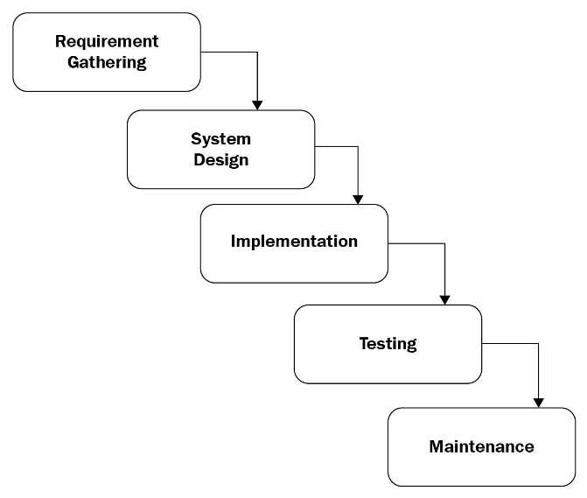

WATERFALL MODEL Figure 4.3

**4.4 GANTT CHART**

lOMoARcPSD|31593198

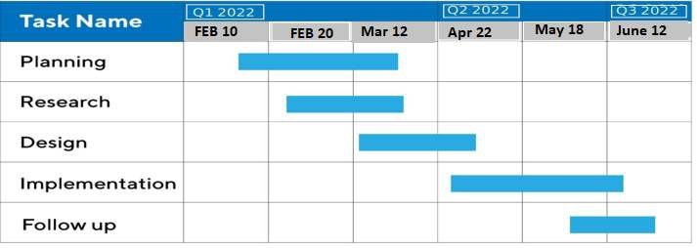

**5.1 FRONTEND**

Front End Approach: o HTML  
o CSS  
o JAVASCRIPT

lOMoARcPSD|31593198

**CHAPTER 5**

___________________________________________________________________________

**TECHNOLOGY**

Hypertext Markup Language is the standard markup language for documents designed to be displayed in a web browser. It can be assisted by technologies such as Cascading Style Sheets (CSS) and scripting languages such as JavaScript.

HTML is used by the browser to manipulate text, images, and other content, to display it in the required format.

HTML elements are the building blocks of HTML pages. With HTML constructs, images, and other objects such as interactive forms may be embedded into the rendered page.

HTML provides a means to create structured documents by denoting structural semantics for text such as headings, paragraphs, lists, links, quotes, and other items.

HTML elements are delineated by tags, written using angle brackets. Tags such as surround and provide information about document text and may include other tags as sub-elements.

HTML page structure: The basic structure of an HTML page is laid out below. It contains the essential building-block elements (i.e., doctype declaration, html, head, title, and body elements) upon which all webpages are created.

HTML5 can be used to write web applications that still work when you're not connected to the net; to tell websites where you are physically located; to handle high-definition video; and to deliver extraordinary graphics.

The core objectives of HTML5 are to offer increased multimedia support and make the coding much easier to read and understand for both people and machines. HTML5 coding is clear, simple, and descriptive.

HTML5 also makes placing audio and video content a breeze. Advantages:  
• HTML is used to build websites.  
• It is supported by all browsers.

• It can be integrated with other languages like CSS, JavaScript etc.

**5.1.2 CSS**

Cascading Style Sheets, fondly referred to as CSS, is a simple design language intended to simplify the process of making web pages presentable.CSS handles the look and feel part of a web page. Using CSS, you can control the color of the text, the style of fonts, the spacing between paragraphs, how columns are sized and laid out, what background images or colors are used, layout designs, variations in display for different devices and screen sizes as well as a variety of other effects.

CSS is easy to learn and understand but it provides powerful control over the presentation of an HTML document. Most commonly, CSS is combined with the markup languages HTML or XHTML.

Types of CSS: Cascading Style Sheet (CSS) is used to set the style in web pages that contain HTML elements. It sets the background color, font-size, font-family, color, etc. Property of elements on a web page. There are three types of CSS which are given below:

* Inline CSS
* Internal or Embedded CSS
* External CSS

Inline CSS: Inline CSS contains the CSS property in the body section attached with element is known as inline CSS. This kind of style is specified within an HTML tag using the style attribute.

Internal CSS: This can be used when a single HTML document must be styled uniquely. The CSS rule set should be within the HTML file in the head section i.e. the CSS is embedded within the HTML file.

External CSS: External CSS contains separate CSS file which contains only style property with

the help of tag attributes (For example class, id, heading, ... etc.). CSS property written in a

separate file with .CSS extension and should be linked to t 25 HTML document using link tag. This means that for each element, style can be set only once and that will be applied across web pages.

Below is the HTML file that is making use of the created external style sheet

• link tag is used to link the external style sheet with the html webpage.  
• href attribute is used to specify the location of the external style sheet file. Advantages Of CSS

* Create Stunning Web Site: CSS handles the look and feel part of a web page. Using CSS, you can control the color of the text, the style of fonts, the spacing between paragraphs, how columns are sized and laid out, what background images or colors are used, layout designs, variations in display for different devices and screen sizes as well as a variety of other effects.
* Become a web designer: If you want to start a career as a professional web designer, HTML and CSS designing is a must skill.
* Control web: CSS is easy to learn and understand but it provides powerful control over the presentation of an HTML document. Most commonly, CSS is combined with the markup languages HTML or XHTML.
* Learn other languages: Once you understand the basic of HTML and CSS then other related technologies like JavaScript, React Js, or angular are become easier

**5.1.3 JAVASCRIPT**

JavaScript is a light-weight object-oriented programming language which is used by several websites for scripting the webpages. It is an interpreted, full-fledged programming language that enables dynamic interactivity on websites when applied to an HTML document. It was introduced in the year 1995 for adding programs to the webpages in the Netscape Navigator browser. Since then, it has been adopted by all other graphical web browsers. With JavaScript, users can build modern web applications to interact directly without reloading the page every time. The traditional website uses Js provide several forms of interactivity and simplicity. Although, JavaScript has no connectivity with Java programming language. The name was suggested and provided in the times when Java was gaining popularity in the market. In addition to web browsers, databases such as CouchDB and MongoDB uses JavaScript as their scripting and query language.

Features of JavaScript

There are following features of JavaScript:

1. All popular web browsers support JavaScript as they provide built-in execution environments.

2. JavaScript follows the syntax and structure of the C programming language. Thus, it is a structured programming language.

3. JavaScript is a weakly typed language, where certain types are implicitly cast (depending on the operation).

4. JavaScript is an object-oriented programming language that uses prototypes rather than using classes for inheritance.

5. It is a light-weighted and interpreted language.

6. It is a case-sensitive language.

7. JavaScript is supportable in several operating systems including, Windows, macOS, etc.

8. It provides good control to the users over the web browsers. Application of JavaScript Java Script is used to create interactive websites.

It is mainly used for:

• Client-side validation,

• Dynamic drop-down menus,

• Displaying date and time,

• Displaying pop-up windows and dialog boxes (like an alert dialog box, confirm dialog box and prompt dialog box),

• Displaying clocks etc.

**CHAPTER 6**

___________________________________________________________________________________

**PLATFORM**

**6.1 VISUAL STUDIO**

Visual Studio is an Integrated Development Environment (IDE) developed by Microsoft to develop GUI (Graphical User Interface), console, Web applications, web apps, mobile apps, cloud, and web services, etc. With the help of this IDE, you can create managed code as well as native code. It uses the various platforms of Microsoft software development software like Windows store, Microsoft Silver light, and Windows API, etc. It is not a language-specific IDE as you can use this to write code in C#, C++, VB (Visual Basic), Python, JavaScript, and many more languages. It is available for Windows as well as for macOS.

**6.2 Evolution of Visual Studio:**

The first version of VS (Visual Studio) was released in 1997, named as Visual Studio 97 having version number 5.0. The latest version of Visual Studio is 15.0 which was released on March 7, 2017. It is also termed as Visual Studio 2017. The supported .NET Framework Versions in latest Visual Studio is 3.5 to 4.7. Java was supported in old versions of Visual Studio but in the latest version doesn’t provide any support for Java language.

**6.3 Getting Started with Visual Studio**

First, you have to download and install the Visual Studio. For that, you can refer to Downloading

and Installing Visual Studio 2017. Don’t forget to select the .NET core workload during the

installation. If you forget then you have to modify the installation. You can see a number of tool windows when you will open the Visual Studio and start writing your first program as follows:

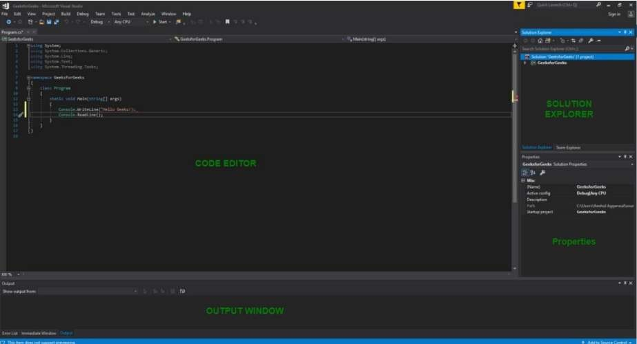

**Code Editor:** Where the user will write code.  
Output Window: Here the Visual Studio shows the outputs, compiler warnings, error messages

and debugging information.  
**Solution Explorer:** It shows the files on which the user is currently working.

**Properties:** It will give additional information and context about the selected parts of the current project.

A user can also add windows as per requirement by choosing them from View menu. In Visual Studio the tool windows are customizable as a user can add more windows, remove the existing open one or can move windows around to best suit. Various Menus in Visual Studio: A user can find a lot of menus on the top screen of Visual Studio as shown below

Various Menus in Visual Studio: A user can find a lot of menus on the top screen of Visual Studio as shown below:

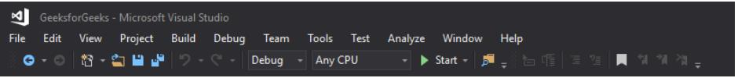

FIGURE 6.2

* Create, Open and save projects commands are contained by File menu.
* Searching, Modifying, Refactoring code commands are contained by the Edit menu.
* View Menu is used to open the additional tool windows in Visual Studio.
* Project menu is used to add some files and dependencies in the project.
* To change the settings, add functionality to Visual Studio via extensions, and access

various Visual Studio tools can be used by using Tools menu.  
The below menu is known as the toolbar which provide the quick access to the most frequently

used commands. You can add and remove the commands by going to View → Customize

FIGURE 6.3

page37image24896240

**CHAPTER 7**

___________________________________________________________________________

**FUTURE SCOPES**

We will improve it further. And we will put payment gateway in it.

We will provide daily quiz to the student

Moreover, it is just a beginning; further the system may be utilized in various other types of auditing operation viz. Network auditing or similar process/workflow-based applications.

This System being web-based and an undertaking of Cyber Security Division, needs to be thoroughly tested to find out any security gaps.

A console for the data Centre may be made available to allow the personnel to monitor on the sites which were cleared for hosting during a particular period.

**9.1 INTRODUCTION**

System Security can be divided into four related issues:

● Security

● Integrity

● Privacy

● Confidentiality

**SYSTEM SECURITY** refers to the technical innovations and procedures applied to the hardware and operation systems to protect against deliberate or accidental damage from a defined threat.

**DATA SECURITY** is the protection of data from loss, disclosure, modification and destruction. 135 Docket Chunk System.

**INTEGRITY** refers to the power functioning of hardware and programs, appropriate physical security and safety against external threats such as eavesdropping and wiretapping.

**PRIVACY** defines the rights of the user or organizations to determine what information they are willing to share with or accept from others and how the organization can be protected against unwelcome, unfair or excessive dissemination of information about it.

**CONFIDENTIALITY** is a special status given to sensitive information in a database to minimize the possible invasion of privacy. It is an attribute of information that characterizes its need for protection.

**9.2 SECURITY SOFTWARE**

System security refers to various validations on data in form of checks and controls to avoid the system from failing. It is always important to ensure that only valid data is entered and only valid operations are performed on the system. The system employees two types of checks and controls:

**CHAPTER 8**

**CODE FOR THE PROGRAM**

**1st page(HTML,CSS and JAVASCRIPT)**

<!DOCTYPE html>

<html lang="en">

<head>

    <meta charset="UTF-8">

    <meta name="viewport" content="width=device-width, initial-scale=1.0">

    <title>Document</title>

    <link rel="stylesheet" href="style.css">

    <link href="https://cdn.jsdelivr.net/npm/remixicon@3.2.0/fonts/remixicon.css" rel="stylesheet">

    <link rel="stylesheet" href="https://cdn.jsdelivr.net/npm/locomotive-scroll@3.5.4/dist/locomotive-scroll.css">

    <link rel="stylesheet" href="https://cdnjs.cloudflare.com/ajax/libs/font-awesome/5.15.4/css/all.min.css">

    <script src="https://unpkg.com/scrollreveal"></script>

</head>

<body>

    <div id="main">

        <div data-scroll data-scroll-speed="-5" id="page1">

            <nav>

                <img src="WhatsApp Image 2023-09-19 at 11.59.09 PM.jpeg" width="80" height="110" alt="">

                <div id="right-nav">

                    <button type="button">Available Courses</button>

                    <button type="button" oneclick="location.href='C:\Users\Prabhat Soni\Desktop\project\another\loginpg\login.html'">Account</button>

                    <button><i class="ri-menu-fill"></i></button>

                </div>

            </nav>

            <img class="rotate_01" src="C:\Users\prabh\OneDrive\Desktop\fee project\a55e849abc4cc538de6db6e7557e2590.png">

            <div class="bottom-page1">

                <h1>Explore Your <br> Potential </h1>

                <div class="bottom-page1-inner">

                    <h4>Chitkara institute provide quality  <br>education with world class facilies.</h4>

                    <button>LEARN MORE</button>

                </div>

            </div>

            <video src="https://thisismagma.com/wp-content/themes/magma/assets/home/hero/1.mp4?2" autoplay loop muted ></video>

        </div>

        <div id="page2">

            <br>

            <h2>WANT TO KNOW WHAT WE TEACH!! <h2>

            <h1>Technology played and continues to play an essential role to deliver education to the students outside of school.

            </h1>

            <a href="C:\Users\prabh\OneDrive\Desktop\fee project\New folder\project.html" class="visit">

                <button type="button" button.style.backgroundColor = "red";> VISIt TO COURSE SELECTION</button>

            </a>

        </div>

                    <div class="right9">

                <div class="right9-center"></div>

            </div>

        </div>

        <script src="https://cdn.jsdelivr.net/npm/locomotive-scroll@3.5.4/dist/locomotive-scroll.js"></script>

        <script src="https://cdnjs.cloudflare.com/ajax/libs/gsap/3.12.1/gsap.min.js" integrity="sha512-qF6akR/fsZAB4Co1QDDnUXWnaQseLGXoniuSuSlPQK6+aWhlMZcHzkasCSlnWoe+TJuudlka1/IQ01Dnhgq95g==" crossorigin="anonymous" referrerpolicy="no-referrer"></script>

        <script src="https://cdnjs.cloudflare.com/ajax/libs/gsap/3.12.1/ScrollTrigger.min.js" integrity="sha512-IHDCHrefnBT3vOCsvdkMvJF/MCPz/nBauQLzJkupa4Gn4tYg5a6VGyzIrjo6QAUy3We5HFOZUlkUpP0dkgE60A==" crossorigin="anonymous" referrerpolicy="no-referrer"></script>

        <script src="script.js"></script>

    <button type="button"></button>

        </body>

        </html>

CSS for front page:

* {

  margin: 0%;

  padding: 0%;

  box-sizing: border-box;

}

html,

body {

  height: 100%;

  width: 100%;

}

.lovisit {

    display: flex;

    align-items: center;

    position: absolute;

    border-radius: 70px;

    top: 30%;

    left: 87%;

    padding: 5px 20px;

    border-radius: 50px;

    background-color: #0b48ed;

    border: 1px solid #fff;

    font-family: a;

    font-size: 15px;

}

#main{

    position: relative;

    overflow: hidden;

    background-color: #1137ca;

}

@font-face {

    font-family: a;

    src: url(./jost-variable.ttf);

}

@font-face {

    font-family: b;

    src: url(./KFOlCnqEu92Fr1MmEU9fBBc4\ \(1\).ttf);

}

@font-face {

    font-family: c;

    src: url(./KFOmCnqEu92Fr1Mu4mxK\ \(1\).ttf);

}

#page1

{

    height: 100vh;

    width: 100vw;

    position: relative;

}

#page1>video{

    height: 100%;

    width: 100%;

    object-fit: cover;

}

#page1>nav{

    display: flex;

    align-items: center;

    justify-content: space-between;

    padding: 0px 30px;

    position: absolute;

    height: 10vh;

    width: 100vw;

}

.logo{

    position: absolute;

    width: 150px;

    height: 150px;

    background: url;

}

image{

    max-width: 50%;

    max-height: 50%;

}

#page1>nav>img{

    margin-top: -1.7vw;

    width: 9%;

}

#right-nav>button{

    padding: 10px 20px;

    border-radius: 50px;

    background-color: #0b48ed;

    border: 1px solid #fff;

    color: #fff;

    font-family: a;

    font-size: 15px;

}

.bottom-page1{

    position: absolute;

    bottom: 5%;

    height: 35vh;

    width: 50vw;

    left: 10%;

}

.bottom-page1>h1{

    font-family: a;

    font-size: 5vw;

    font-weight: 100;

    line-height: 1;

    color: #fff;

}

.bottom-page1-inner{

    position: absolute;

    bottom: 0%;

    height: 35%;

    width: 100%;

}

.bottom-page1-inner{

    display: flex;

    align-items: center;

    justify-content: space-between;

    font-family: a;

}

.bottom-page1-inner>button{

    padding: 10px 20px;

    border: none;

    border-radius: 50px;

    background-color: #fff;

    color: #0b48ed;

    font-size: 16px;

    font-family: b;

}

.bottom-page1-inner>h4{

    font-size: 1.3vw;

    font-weight: 100;

    color: #fff;

}

#page2{

    display: flex;

    align-items: start;

    font-family: a;

    justify-content: center;

    flex-direction: column;

    height: 100vh;

    width: 100vw;

    position: relative;

    padding: 0vw 8vw;

    color: #fff;

    background-color: #0a3cce;

}

#page2>h2{

    margin-bottom: 3vw;

    font-weight: 100;

}

#page2>h1{

    font-weight: 100;

    line-height: 1.3;

    width: 90%;

    font-size: 4vw;

    color: #dadada69;

}

.right9{

    height: 100%;

    width: 60%;

    position: relative;

}

.right10-inner>p{

    margin-top: 2vw;

    font-size: 1.3vw;

    width: 80%;

}

.center14{

    height: 0%;

    width: 100%;

    background-color: #0a3cce;

    position: absolute;

    left: 50%;

    top: 50%;

    transform: translate(-50%,-50%);

    transition: all ease .5s;

}

.visit {

    color: white;

    display: flex;

    align-items: center;

    position: absolute;

    border-radius: 70px;

    top: 80%;

    left: 50%;

    padding: 5px 20px;

    border-radius: 50px;

    background-color: #0b48ed;

    border: 1px solid #fff;

    font-family: a;

    font-size: 15px;

}

.rotate_01:hover{

    -webkit-transform: rotate(360deg) translateZ(0);

}

.rotate_01{

    top: 30%;

    left: 3%;

    position: fixed;

    width: 210px;

    height: 210px;

    margin: -60px 0 0 150px;

    -webkit-animation: spin 1s linear infinite;

    -moz-animation: spin 1s linear infinite;

    animation: spin 1s linear infinite;

}

/*use keyframes*/

@-webkit-keyframes spin{

    100%{-webkit-transform: rotate(360deg);}

}

@-moz-keyframes spin{

    100%{-webkit-transform: rotate(360deg);}

}

@keyframes spin{

    100%{-webkit-transform: rotate(360deg);}

}

**JAVASCRIPT**

function loco(){

    gsap.registerPlugin(ScrollTrigger);

const locoScroll = new LocomotiveScroll({

  el: document.querySelector("#main"),

  smooth: true

});

locoScroll.on("scroll", ScrollTrigger.update);

ScrollTrigger.scrollerProxy("#main", {

  scrollTop(value) {

    return arguments.length ? locoScroll.scrollTo(value, 0, 0) : locoScroll.scroll.instance.scroll.y;

  },

  getBoundingClientRect() {

    return {top: 0, left: 0, width: window.innerWidth, height: window.innerHeight};

  },

  pinType: document.querySelector("#main").style.transform ? "transform" : "fixed"

});

ScrollTrigger.addEventListener("refresh", () => locoScroll.update());

ScrollTrigger.refresh();

}

loco()

var clutter = "";

document.querySelector("#page2>h1").textContent.split("").forEach(function(dets){

    clutter += `<span>${dets}</span>`

    document.querySelector("#page2>h1").innerHTML = clutter;

})

gsap.to("#page2>h1>span",{

    scrollTrigger:{

        trigger:`#page2>h1>span`,

        start:`top bottom`,

        end:`bottom top`,

        scroller:`#main`,

        scrub:.5,

    },

    stagger:.2,

    color:`#fff`

})

function canvas(){

    const canvas = document.querySelector("#page3>canvas");

const context = canvas.getContext("2d");

canvas.width = window.innerWidth;

canvas.height = window.innerHeight;

window.addEventListener("resize", function () {

  canvas.width = window.innerWidth;

  canvas.height = window.innerHeight;

  render();

});

const frameCount = 67;

const images = [];

const imageSeq = {

  frame: 1,

};

for (let i = 0; i < frameCount; i++) {

  const img = new Image();

  img.src = files(i);

  images.push(img);

}

gsap.to(imageSeq, {

  frame: frameCount - 1,

  snap: "frame",

  ease: `none`,

  scrollTrigger: {

    scrub: .5,

    trigger: `#page3`,

    start: `top top`,

    end: `250% top`,

    scroller: `#main`,

  },

  onUpdate: render,

});

images[1].onload = render;

function render() {

  scaleImage(images[imageSeq.frame], context);

}

function scaleImage(img, ctx) {

  var canvas = ctx.canvas;

  var hRatio = canvas.width / img.width;

  var vRatio = canvas.height / img.height;

  var ratio = Math.max(hRatio, vRatio);

  var centerShift_x = (canvas.width - img.width * ratio) / 2;

  var centerShift_y = (canvas.height - img.height * ratio) / 2;

  ctx.clearRect(0, 0, canvas.width, canvas.height);

  ctx.drawImage(

    img,

    0,

    0,

    img.width,

    img.height,

    centerShift_x,

    centerShift_y,

    img.width * ratio,

    img.height * ratio

  );

  }

COURSE PAGE (HTML,CSS AND JAVASCRIPT)

HTML

<!DOCTYPE html>

<html lang="en">

  <head>

    <meta charset="UTF-8" />

    <meta http-equiv="X-UA-Compatible" content="IE=edge" />

    <meta name="viewport" content="width=device-width, initial-scale=1.0" />

    <title>Document</title>

    <link rel="stylesheet" href="style.css" />

  </head>

  <body>

    <video id="background-video" autoplay loop muted >

      <source src="video (2160p).mp4" type="video/mp4">

      </video>

  </video>

    <div class="card">

      <div class="imgbox">

        <img

          src="https://images.pexels.com/photos/8438923/pexels-photo-8438923.jpeg?auto=compress&cs=tinysrgb&w=600"

        />

      </div>

      <div class="content">

        <h2>MACHINE LEARNING</h2>

        <p>

         EXPLORE THE POTENTIAL OF MACHINE LEARNING WITH OUR COURSE

        </p>

      </div>

    </div>

    <div class="card">

      <div class="imgbox">

        <img

          src="https://images.pexels.com/photos/373543/pexels-photo-373543.jpeg?auto=compress&cs=tinysrgb&w=600"

        />

      </div>

      <div class="content">

        <h2>AI</h2>

        <p>

          AI UNLEASED:LEARN HOW TO USE AI AT ITS FULL POTENTIAL IN OUR DAILY LIVES

        </p>

      </div>

    </div>

    <div class="card">

      <div class="imgbox">

        <img

          src="https://images.pexels.com/photos/965345/pexels-photo-965345.jpeg?auto=compress&cs=tinysrgb&w=600"

        />

      </div>

      <hr>

      <div class="content">

        <h2>PYTHON</h2>

        <p>

         LEARN ONE OF THE MOST FAMOUS AND EASY TO LEARN LANGUAGE AT ITS FINEST UNDER THE GUIDENCE OF OUR EXPERIENCED TEACHER

        </p>

      </div>

    </div>

  </body>

</html>

CSS

body {

    height: 100vh;

    display: flex;

    justify-content: center;

    align-items: center;

    font-family: "Raleway", Arial, sans-serif;

    background: #0a43e4;

  }

#background-video {

  width: 100vw;

  height: 100vh;

  object-fit: cover;

  position: fixed;

  left: 0;

  right: 0;

  top: 0;

  bottom: 0;

  z-index: -1;

}

  .card {

    position: relative;

    width: 300px;

    height: 200px;

    border-radius: 10px;

    box-shadow: 0px 5px 20px rgba(0, 0, 0, 0.5);

    transition: 0.3s;

    padding: 30px 50px;

    background: #fff;

    cursor: pointer;

    margin-right: 30px;

  }

  .card:hover {

    height: 320px;

  }

  .imgbox {

    position: relative;

    width: 100%;

    height: 100%;

    transform: translateY(-80px);

    z-index: 99;

  }

  img {

    width: 100%;

    border-radius: 10px;

    box-shadow: 0px 5px 20px rgba(0, 0, 0, 0.5);

  }

  .content {

    padding: 10px 20px;

    text-align: center;

    transform: translateY(-450px);

    opacity: 0;

    transition: 0.3s;

  }

  .card:hover > .content {

    opacity: 1;

    transform: translateY(-180px);

  }

  .content h2 {

    color: #7f9ead;

  }

  .back {

    position: absolute;

    right: 0;

    bottom: 0;

    z-index: -1;

  }

LOGIN PAGE (HTML,CSS)

HTML

<!DOCTYPE html>

   <html lang="en">

   <head>

      <meta charset="UTF-8">

      <meta name="viewport" content="width=device-width, initial-scale=1.0">

      <link rel="stylesheet" href="https://cdnjs.cloudflare.com/ajax/libs/remixicon/3.5.0/remixicon.css" crossorigin="">

      <link rel="stylesheet" href="assets/css/styles.css">

      <title>Login form</title>

   </head>

   <body>

      <div class="login">

         <img src="assets/img/login-bg.png" alt="image" class="login__bg">

         <form action="" class="login__form">

            <h1 class="login__title">Login</h1>

            <div class="login__inputs">

               <div class="login__box">

                  <input type="email" placeholder="Email ID" required class="login__input">

                  <i class="ri-mail-fill"></i>

               </div>

               <div class="login__box">

                  <input type="password" placeholder="Password" required class="login__input">

                  <i class="ri-lock-2-fill"></i>

               </div>

            </div>

            <div class="login__check">

               <div class="login__check-box">

                  <input type="checkbox" class="login__check-input" id="user-check">

                  <label for="user-check" class="login__check-label">Remember me</label>

               </div>

               <a href="#" class="login__forgot">Forgot Password?</a>

            </div>

            <button type="submit" class="login__button">Login</button>

            <div class="login__register">

               Don't have an account? <a href="#">Register</a>

            </div>

         </form>

      </div>

   </body>

</html>

CSS

@import url("https://fonts.googleapis.com/css2?family=Poppins:wght@400;500;600&display=swap");

* {

  box-sizing: border-box;

  padding: 0;

  margin: 0;

}

body,

input,

button {

  font-family: var(--body-font);

  font-size: var(--normal-font-size);

}

a {

  text-decoration: none;

}

img {

  display: block;

  max-width: 100%;

  height: auto;

}

.login {

  position: relative;

  height: 100vh;

  display: grid;

  align-items: center;

}

.login__bg {

  position: absolute;

  width: 100%;

  height: 100%;

  object-fit: cover;

  object-position: center;

}

.login__form {

  position: relative;

  margin-inline: 1.5rem;

  background-color: hsla(0, 0%, 100%, .01);

  border: 2px solid hsla(0, 0%, 100%, .7);

  padding: 2.5rem 1rem;

  color: var(--white-color);

  border-radius: 1rem;

  backdrop-filter: blur(16px);

}

.login__title {

  text-align: center;

  font-size: var(--h1-font-size);

  margin-bottom: 1.25rem;

}

.login__inputs,

.login__box {

  display: grid;

}

.login__inputs {

  row-gap: 1.25rem;

  margin-bottom: 1rem;

}

.login__box {

  grid-template-columns: 1fr max-content;

  column-gap: .75rem;

  align-items: center;

  border: 2px solid hsla(0, 0%, 100%, .7);

  padding-inline: 1.25rem;

  border-radius: 4rem;

}

.login__input,

.login__button {

  border: none;

  outline: none;

}

.login__input {

  width: 100%;

  background: none;

  color: var(--white-color);

  padding-block: 1rem;

}

.login__input::placeholder {

  color: var(--white-color);

}

.login__box i {

  font-size: 1.25rem;

}

.login__check,

.login__check-box {

  display: flex;

  justify-content: space-between;

  align-items: center;

}

.login__check {

  margin-bottom: 1rem;

  font-size: var(--small-font-size);

}

.login__check-box {

  column-gap: .5rem;

}

.login__check-input {

  width: 1rem;

  height: 1rem;

  accent-color: var(--white-color);

}

.login__forgot {

  color: var(--white-color);

}

.login__forgot:hover {

  text-decoration: underline;

}

.login__button {

  width: 100%;

  padding: 1rem;

  margin-bottom: 1rem;

  background-color: var(--white-color);

  border-radius: 4rem;

  color: var(--black-color);

  font-weight: 500;

  cursor: pointer;

}

.login__register {

  font-size: var(--small-font-size);

  text-align: center;

}

.login__register a {

  color: var(--white-color);

  font-weight: 500;

}

.login__register a:hover {

  text-decoration: underline;

}

VIDEO PAGE (HTML ,CSS)

<!DOCTYPE html>

<html lang="en">

<head>

    <meta charset="UTF-8">

    <meta name="viewport" content="width=device-width, initial-scale=1.0">

    <title>Video Player</title>

    <link rel="stylesheet" href="styles.css">

</head>

<body>

    <div class="video-player">

        <video id="video" controls>

            <source src="C:\Users\prabh\OneDrive\Desktop\New folder\video\any question.mp4" type="video/mp4">

        </video>

    </div>

</body>

</html>

CSS  
body {

    background-color: #222;

    color: #fff;

    font-family: Arial, sans-serif;

    display: flex;

    justify-content: center;

    align-items: center;

    height: 100vh;

    margin: 0;

}

.video-player {

    background-color: #333;

    padding: 20px;

    border-radius: 5px;

    max-width: 900px;

    box-shadow: 0 0 20px rgba(0, 0, 0, 0.5);

}

video {

    width: 100%;

    height: auto;

}

**CHAPTER 9**

___________________________________________________________________________

**Collaborating with GitHub**

**Create a distributed Repository and add members in project team-**

**Sign in to GitHub:**

Open your web browser and navigate to GitHub’s website. Sign in to your GitHub account if you have already.

**Create a New Repository:**

Click on the “+” icon in the top-right corner of the GitHub interface.

Select “New repository” from the dropdown menu.

Fill in the repository name,description,and other details as needed.

Choose whether the repository will be public or private.

Click on “Create Repository” to create this repository.

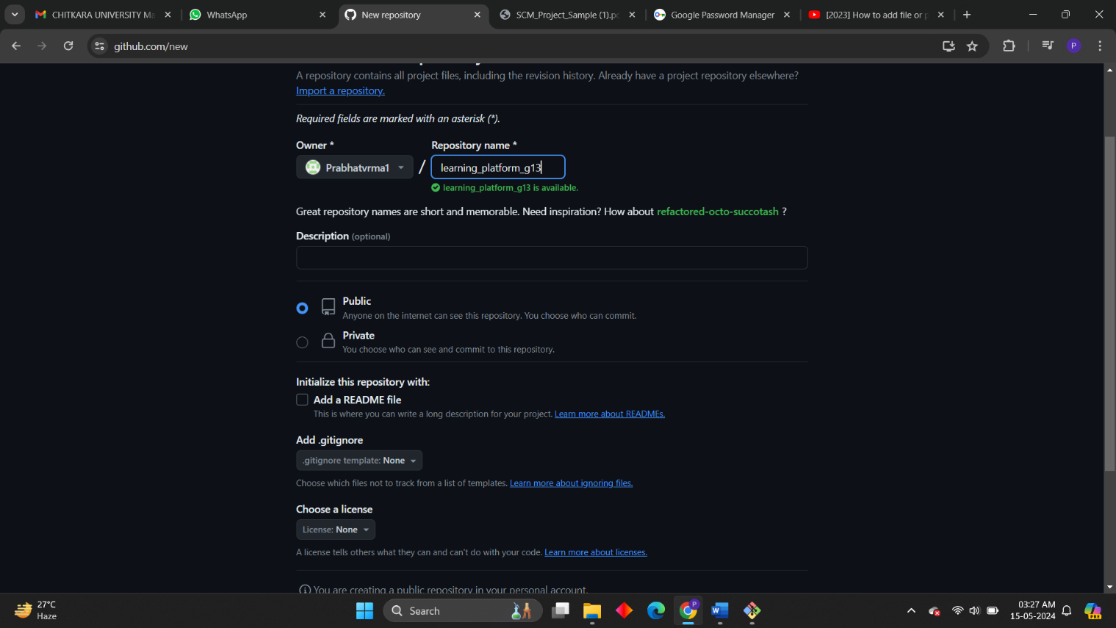

**Invite Collaborators:**

Once your repository is created, navigate to its page on GitHub.

Click on the "Settings" tab.

In the left sidebar, select "Manage access."

Click on the "Invite a collaborator" button.

Type in the GitHub username, email address, or name of the person you want to invite as a collaborator.

Select the appropriate user from the dropdown list.

Choose the permission level for the collaborator (e.g., read, write, or admin).

Once your repository is created, navigate to its page on GitHub.

Click on "Add [username]" to send the invitation.

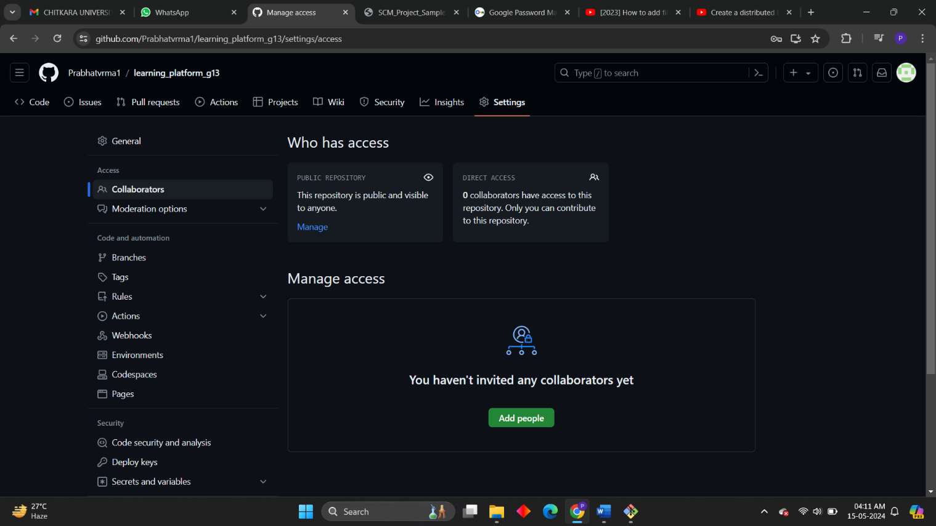

**Accept Invitations:**

Invited collaborators will receive an email notification and a notification on GitHub.

They need to accept the invitation by clicking on the link provided in the email or the notification.

Once they accept, they'll have access to the repository according to the permission level you assigned.

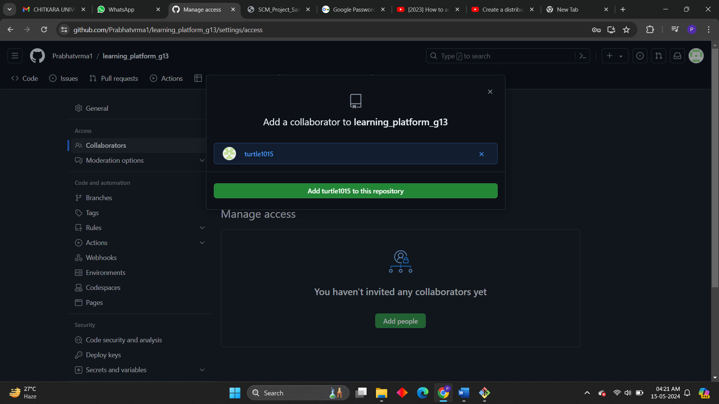

**Clone the Repository:**

Collaborators who have accepted the invitation can clone the repository to their local machine using Git.

They can do this by copying the repository URL from GitHub and using the git clone command in their terminal or Git GUI tool.

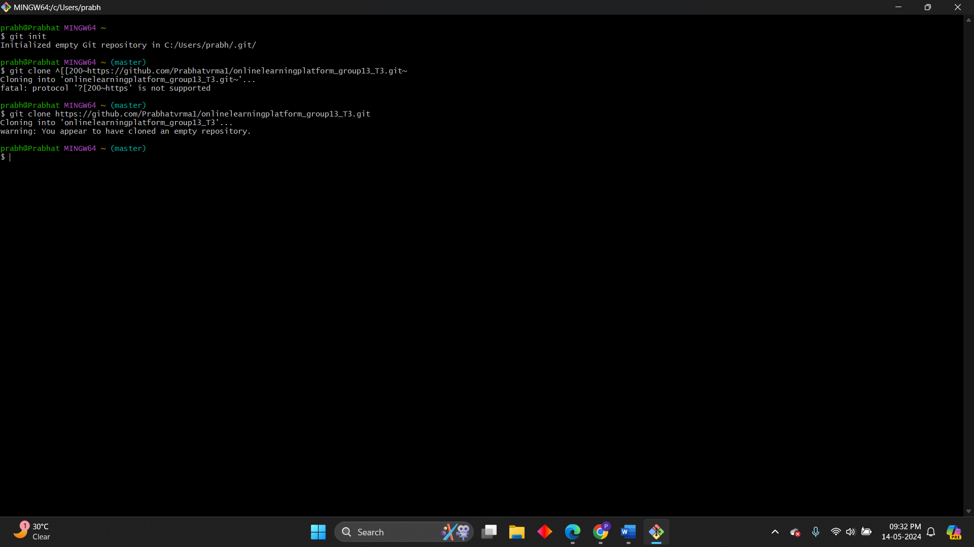

**Collaborate on Code:**

Collaborators can now push changes to the repository, create branches, open pull requests, review code, and perform other collaborative actions as per their permission level.

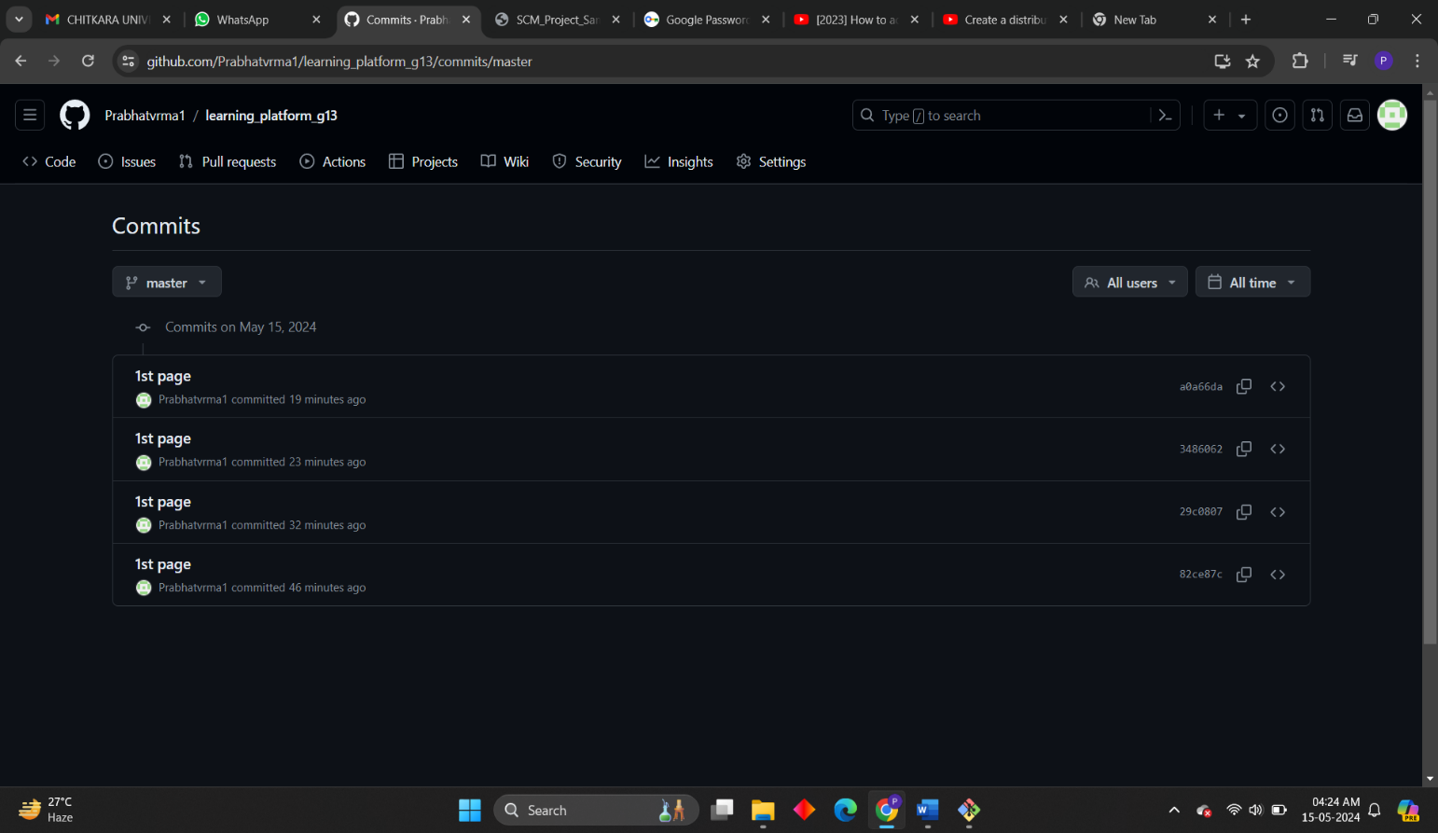

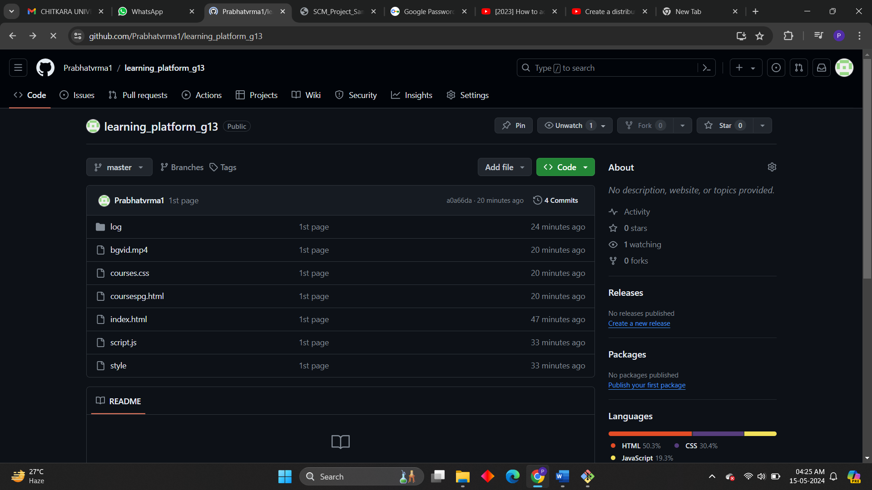

**Open and close a pull request.**

**Opening a Pull Request:**

Navigate to the Repository:

Go to the GitHub repository where you want to open a pull request.

Create a New Branch (if necessary):

If you haven't already made changes on a separate branch, it's a good practice to create a new branch for your changes. You can do this by clicking on the branch dropdown and typing in a new branch name. Then, press Enter.

**Make Changes:**

Make the necessary changes to the codebase on your branch. You can do this by editing existing files or adding new ones.

**Commit Changes:**

Once you've made your changes, commit them to your branch with descriptive commit messages. You can do this directly on GitHub by clicking on the "Add file" or "Edit" buttons, or you can make the changes locally and push them to your branch.

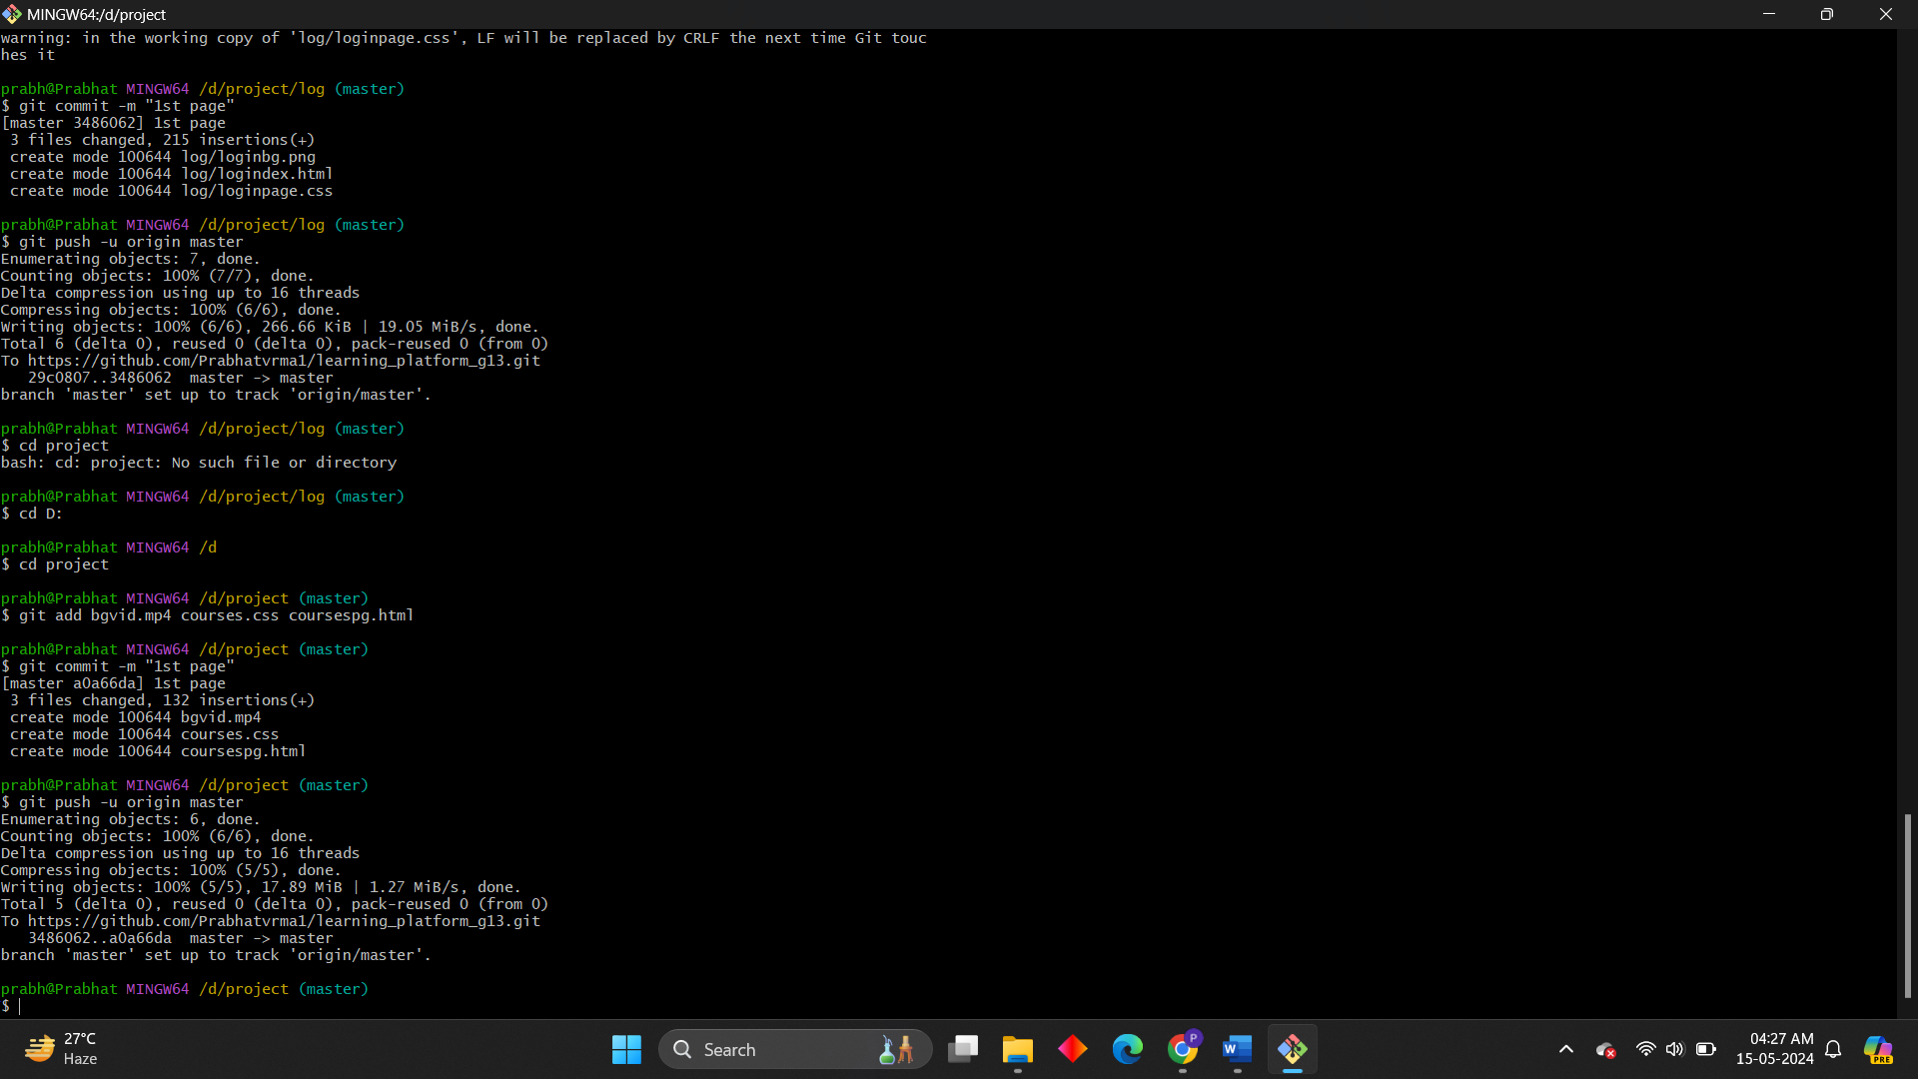

**Initiate PUSH/Pull Request:**

After committing your changes, navigate back to the repository's main page.

You should see a banner indicating that you recently pushed a

branch, with a button to "Compare & pull request." Click on this

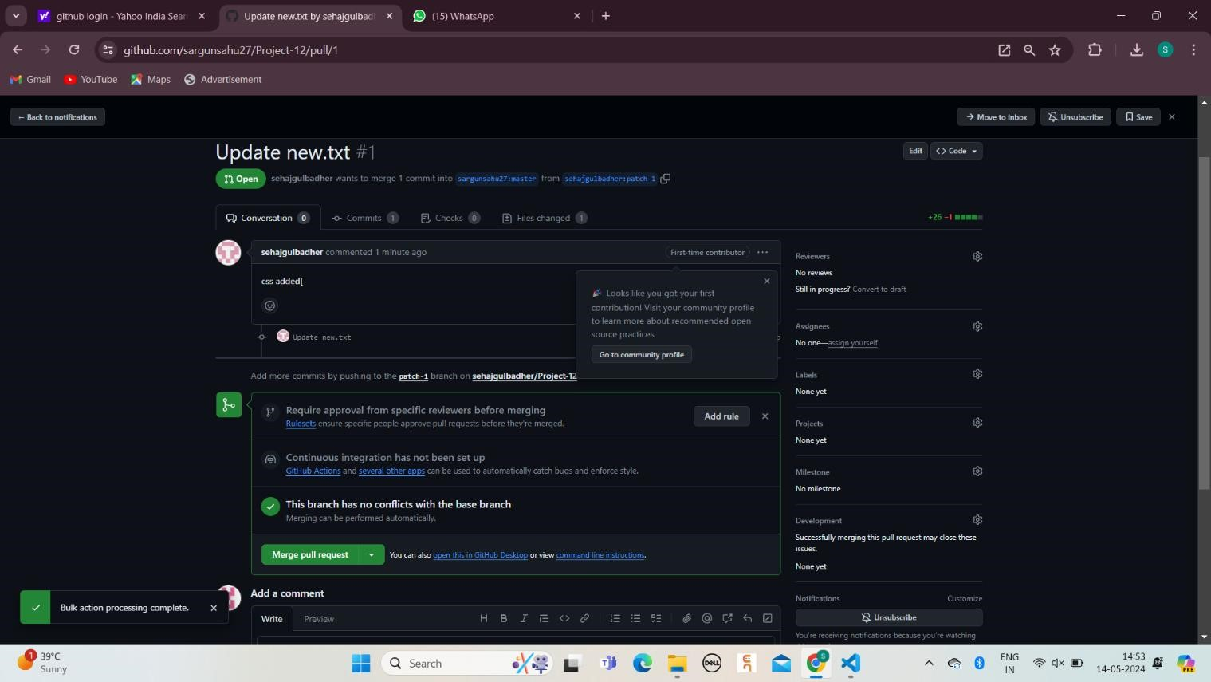

**Conflicts Due to Collaborator**

Working with version control systems such as Git, most merge conflicts resolve automatically. However, there are situations where git merge is unable to resolve an issue.

Since the problem happens locally and the rest of the project members are unaware of the issue, resolving the conflict is of high priority and requires an immediate fix.

Types Of Git Merge Conflicts

The general types of merge conflicts depend on when the issue appears. The conflicts happen either:

* Before merging
* During the merge

A. Steps for resolving conflicts created due to own activity in repository:

1. Firstly, created a new repository and add some file in the repo and make some changes in it and push it on the cloud with the help of git command “git push”.

(i.e.; as we have done these all work in above experiments or if you haven’t done this before, please complete above experiments then proceed to experiment 08)

1. Now, unfortunately user have make the changes on his/her local machine and also on the cloud in the same repo and and same file, when user trying to push local change to cloud the git will rejected it (i.e.; as shown in picture given below). So, to resolve this error user have to run a command “git pull”
2. Now, run git push and you can no conflict error will come. We successfully resolve the own activity conflict error.

B. Steps to resolve conflicts created due to collaborators activity:

This is very similar to own activity conflict the main difference in this is conflict occur due to the collaborator activity, if user make some changes in local machine and collaborator also make changes on cloud in the same repository and same file then conflict error will occur.

To resolve this conflict, follow the same steps which are done to resolve own activity conflict, use editor tools or just simply edits directly form file.

**Uploading Project on GitHub:**

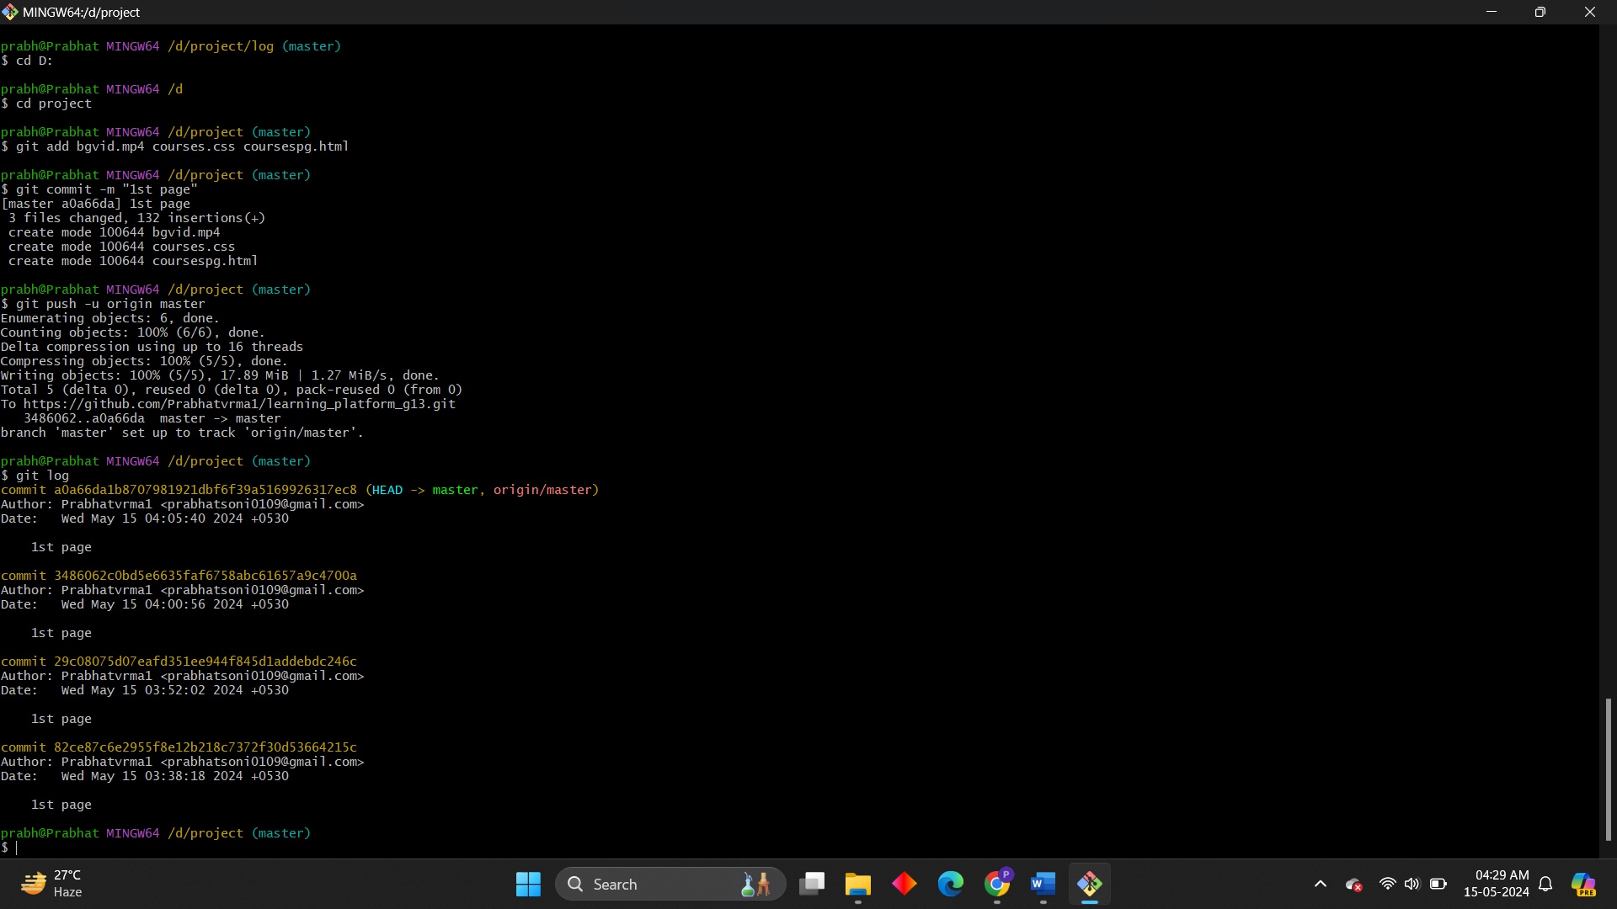

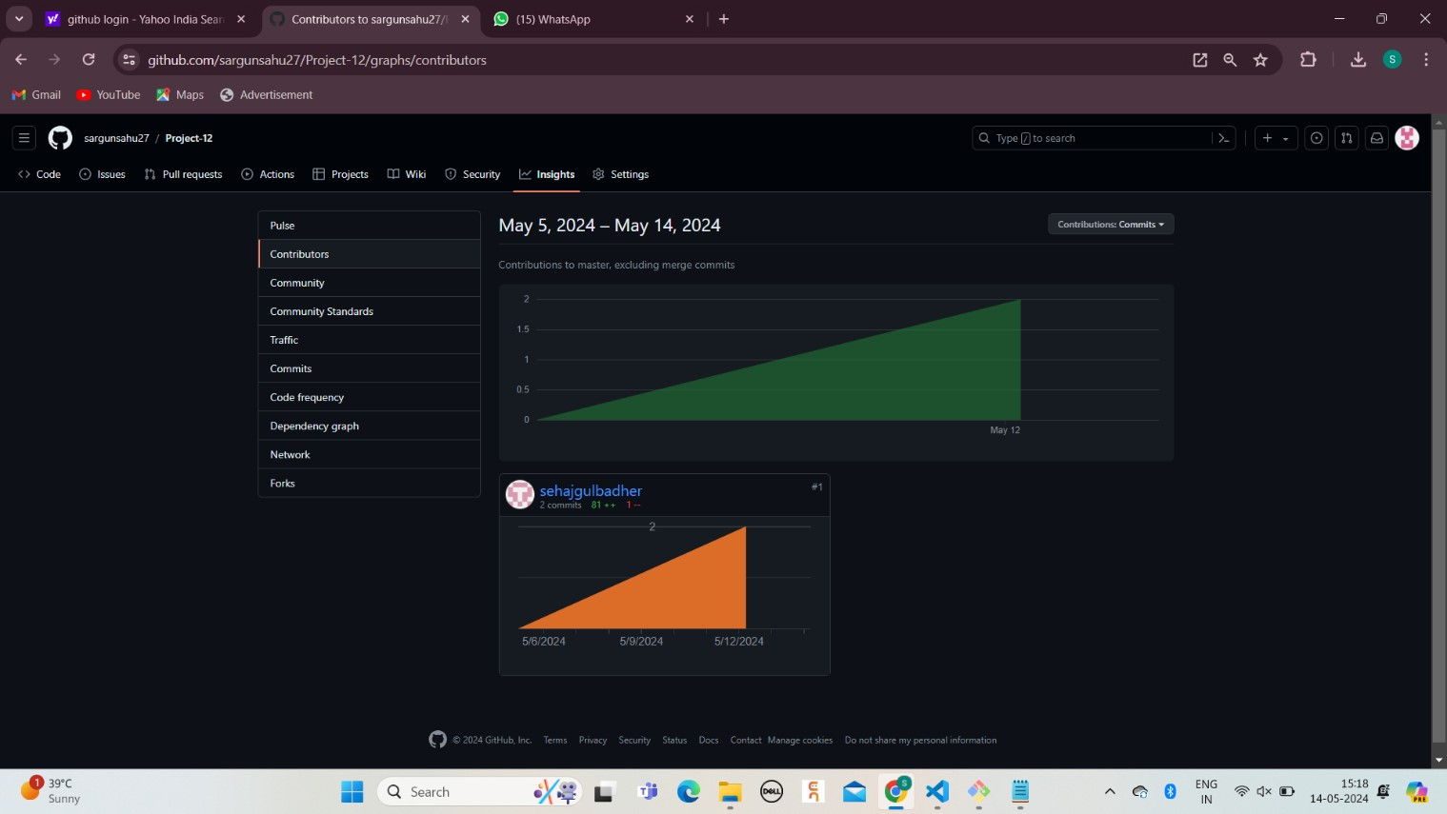

**CHAPTER 10**

___________________________________________________________________________

**CONCLUSIONS**

It has been a great pleasure for me to work on this exciting and challenging project. This project proved good for me as it provided practical knowledge of not only in HTML, CSS and JavaScript web-based application and no some extent Windows Application and SQL Server, but also about backend language PHP. It also provides knowledge about the latest technology used in developing web enabled application. This will provide better opportunities and guidance in future in developing projects independently.

Finally, I would like to express myself as to how I find this process of developing a system to be very awaking to the mind of a student and to learn how to and teach themselves things. I have built a skill of how to search for things and develop then to my needs. It has indeed been a great experience.

**8.1 BENEFITS  
1.E- Learning Accommodates Everyone’s Needs**

The online method of learning is best suited for everyone. This digital revolution has led to remarkable changes in how the content is accessed, consumed, discussed, and shared. Online educational courses can be taken up by office goers and housewives too, at the time that suits them. Depending on their availability and comfort, many people choose to learn at weekends or evenings.

**2. Lectures Can Be Taken Any Number of Times**

Unlike classroom teaching, with online learning you can access the content an unlimited number of times. This is especially required at the time of revision when preparing for an exam. In traditional form of learning, if you cannot attend the lecture, then you have to prepare for that topic on your own; in eLearning, you can attend the lectures whenever you want with ease.

**3. Offers Access to Updated Content**

A prime benefit of learning online is that it makes sure that you are in synchronization with modern learners. This enables the learner to access updated content whenever they want it.

content and digest it:

**4. Quick Delivery of Lessons**

eLearning is a way to provide quick delivery of lessons. As compared to traditional classroom teaching method, this mode has relatively quick delivery cycles. This indicates that the time required to learn is reduced to 25%-60% of what is required in traditional learning. There are some of the reasons why the learning time is reduced by eLearning:

* Lessons starts quickly and also wrapped up in a single learning session. This enables training programs to easily roll out within a few weeks, or sometime even days.
* Learners can define their own speed of learning instead of following the speed of the whole group.
* Saves time as a student does not need to travel to the training venue. You can learn at the comfort of your own place.
* Students can choose to study specific and relevant areas of the learning material without focusing on each and every area. For example, they can skip certain areas they do not want to learn.

**5. Scalability**

eLearning helps in creating and communicating new training, policies, concepts, and ideas. Whether it is for formal education or entertainment, eLearning is very quick way of learning!

**6. Consistency**

eLearning enables educators to get a higher degree of coverage to communicate the message in a consistent way for their target audience. This ensures that all learners receive the same type of training with this learning mode.

**7. Reduced Costs**

eLearning is cost effective as compared to traditional forms of learning. The reason for this price reduction is because learning through this mode happens quickly and easily. A lot of training time is reduced with respect to trainers, travel, course materials, and accommodation.

This cost effectiveness also helps in enhancing the profitability of an organization. Also, when you are studying at your own place, you are relieved from paying for travel expenses (e.g. accommodation) when training happens in another city/state and/or external learning materials.

**8. Effectiveness**

eLearning has a positive influence on an organization’s profitability. It makes it easy to grasp the

* It results in improved scores on certifications, tests, or other types of evaluation.
* Higher number of students who achieve ‘pass’ or mastery’ level.
* Enhanced ability to learn and implement the new processes or knowledge at the workplace.
* Help in retaining information for a longer time.

**CHAPTER 11**

___________________________________________________________________________

**REFERENCE**

**Website:**

**www.google.com www.youtube.com www.geeksforgeeks.com www.tech2etc.com**

**www.google.com**

[**www.youtube.com**](http://www.youtube.com)

[**www.geeksforgeeks.com**](http://www.geeksforgeeks.com)

**www.gtihub.com**

**www.github-scm.com**